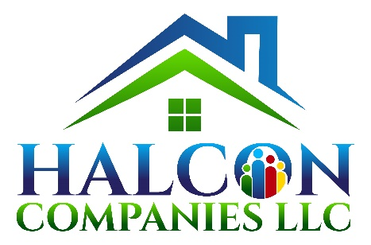

HALCON COMPANIES, LLC
Contact: Traci Dusenbury Tate
2615 Anderson Hwy, Suite B
Powhatan, VA 23139
Office: (804) 376-7674, ext. 0
Mobile: (919) 741-9328
traci@halconcompanies.com

Halcon Companies, LLC is a Virginia Certified SWAM. It was formed in 2009 by Traci Dusenbury Tate, who is the Founder / Managing Member and the entity is a for-profit, woman-owned development company. Halcon is located in Virginia but has a strong presence in North Carolina and the Southeast. Halcon currently has 4 full-time staff members and several part-time staff and interns. Halcon has been an owner in twenty-two (22) LIHTC developments, totaling 1,394 units. Twenty-one (21) of these developments have been in NC and one (1) was in Virginia. In 2018, Halcon Development, LLC, our affiliated ownership entity, was presented the “Housing NC Award” by the NC Housing Finance Agency for outstanding achievement in affordable housing for a LIHTC redevelopment in Asheboro, NC.
Halcon’s founder and Managing Member, Traci Dusenbury Tate, has 25-years’ experience developing LIHTC communities in NC, having previously worked as the Executive Director of the nonprofit Western NC Housing Partnership, Inc., as a Developer for Regency Development Associates, Inc. (owned by SunTrust Bank) and as a Developer for Douglas Development, prior to working for herself. Across her professional history, she has experience developing over 50 successful LIHTC 4% and 9% communities in NC. Additionally, she has a Master’s degree in City and Regional Planning and a background in Planning and Community Development for local governments. Through this work, she became an experienced CDBG and HOME Administrator. This work experience has led to her working with many municipalities who have contributed HOME and/or CDBG funds for LIHTC developments including the City of Suffolk, City of Asheville, the City of Winston-Salem, the City of Raleigh, Wake County, the City of Greensboro, the City of Gastonia, the City of Oxford, the City of Suffolk, VA, the Unifour Housing Consortium (part of Western Piedmont Council of Governments), the City of Hickory, the City of Charlotte, the City of Fayetteville, and many others. All of the LIHTC developments utilizing these funds were completed successfully without any issues with HUD, on-time and in compliance with all regulations including Section 3 and Davis-Bacon. Halcon also consults with other LIHTC developers, for-profit and non-profit, local governments and housing authorities to assist with their development needs. Halcon has been very successful assisting developers with secure gap financing for their developments through Federal Home Loan Banks of Atlanta and Boston, local government CDBG or HOME entitlements or through State Agencies such as the VA Department of Housing and Community Development (DHCD), NC Department of Commerce, NC DSS (ISHP), Section 8, as well as procuring RFP’s.
Ms. Dusenbury Tate is also a licensed real estate broker and broker-in-charge in NC and VA and formed Halcon Properties, LLC as her licensed real estate firm. This affiliated company is also a Certified SWAM for those looking for SWAM-certified real estate brokers. Besides developing her own properties, Halcon also consults with local governments and partners with other for-profit and non-profit developers to help them develop LIHTC communities and Halcon is currently working with developers across NC and across the Country who are developing LIHTC developments in the Southeast.

HAMILTON EQUITABLE HOUSING, LLC
Attn: Shawn Hamilton
2717 Anwell Drive
N. Chesterfield, VA 23235
Office: (804) 376-7695
Mobile: (804) 300-0634
shawn@hamiltonequitablehousing.com/ shawn.hamilton@gmail.com

Hamilton Equitable Housing, LLC was formed in 2022 and is currently seeking it’s SWAM certification. The entity is a Minority Owned, Woman-Owned Small Business. Rochonda “Shawn” Hamilton previously worked at HOME Living Opportunities in Richmond as Certified Homebuyer Education and also did trainings on financial planning, closings, and eviction prevention. She has also trained on fair housing and served as a fair housing inspector. She has also served as a Patient Advocate for HCA and provided outreach and supportive service plans for Halcon Companies, LLC. Her interest and concern for people not being able to find safe, decent, affordable housing has led her to create her entity and to get involved in rental development and affordable home production.

